

MAKING GAMES SINCE 2000
http://thisispop.com

Adult Swim Games/

Gentleman Biker Goes Wild!
Created Wednesday December 23rd, 2009

I. Overview

Gentlemen and… urrrr… Gentlemen, please properly adjust your monocles, fasten each of your several buckles, and properly twirl your mustaches – for it is time to take to the open roads of Southwarkshire! In this gentlemen’s game of the highest class, our top-hatted colleagues take to their high-wheeled 1870s penny-farthing bicycles for a deadly race of manners and privilege. Trade Oscar Wilde-esque quips with your compatriots while doing your best not to hit a out-of-place cobblestone – because while the ride up there may be smooth, it’s a long way down. And the peasants are always out to feast upon your gentlemanly blood.

II. Research

TG Motocross 2 (Flash)

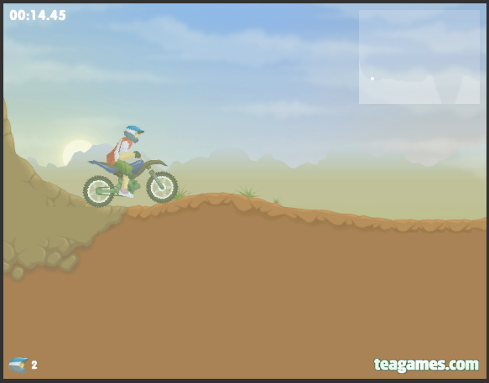

http://www.teagames.com/games/tgmotocross2/play.php

TG Motocross 2 is an example of the popular physics-based vehicle genre. Usually 2D side-scrollers, games such as TG Motocross have the player attempting various tricks or beating best times while avoiding crashing their vehicle.

Chair Chasers (PC)

High-concept Chair Chasers is a freeware game developed by students at Konami’s Computer Entertainment School.

Review: http://www.gamesetwatch.com/2006/03/column_the_gaijin_restoration_2.php

720° (Arcade)

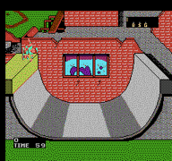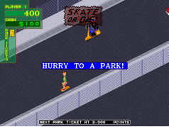

Classic arcade / NES game 720° was the first extreme sports videogame, and probably the best-executed of its era. In 720°, a combination of timing-based tricks and scrolling obstacle and slalom courses gave the game a large variety of play. The game spawned a number of imitators, including also-popular Skate or Die!

The NES ROM can be played online at http://www.nintendo8.com/game/428/720_degrees/.

Freeverse Wingnuts Motochaser (iPhone)

Wingnuts Motochaser is the current gold standard for motorcycle racing on the iPhone. The controls are smooth and the auto-accelerate option lets players focus on the nuances of the road. Like Road Rash, players can punch bothersome riders out of their way – we like that the punch button only appears when the riders are in range.

Review: http://www.ilounge.com/index.php/reviews/entry/freeverse-moto-chaser-wingnuts-motoracer/

